SIMATS ENGINEERING

ASSESSMENT TOOL 2

COURSE NAME: INTERNET PROGRAMMING COURSE CODE: CSA4308

NAME: V ASWINI PAVAN KUMAR
REGISTER NUMBER: 192372151

1: HTTP Response Analysis

A web server returns the following HTTP response header:
HTTP/1.1 200 OK
Date: Mon, 01 Apr 2026 10:00:00 GMT
Content-Type: text/html Content-Length: -150 Connection: keep-alive Questions:

- Identify any incorrect or invalid fields in the header.

The following field is incorrect:
Content-Length: -150
- Content-Length cannot be negative.
- It must contain a non-negative integer representing the number of bytes in the response body.
All other fields (HTTP/1.1, 200 OK, Date, Content-Type, and Connection) are valid.

- Analyze the issue with Content-Length and explain its impact.
The header contains:
Content-Length: -150

Issue:
- A negative content length is invalid according to the HTTP specification.
Impact:
- Browsers may reject the response.
- The client cannot determine the correct size of the response body.
- The webpage may fail to load correctly or the connection may be terminated.

- Determine whether the status code matches the response correctness.

The status code is:
200 OK
- 200 OK means the request was processed successfully.
- However, because the header contains an invalid Content-Length, the response is not completely correct.
- Therefore, the status code indicates success, but the response header contains an error that should be fixed.

- Suggest corrections for the identified errors.
The corrected HTTP response should be:

HTTP/1.1 200 OK
Date: Mon, 01 Apr 2026 10:00:00 GMT
Content-Type: text/html
Content-Length: 150
Connection: keep-alive
Corrections:
- Replace Content-Length: -150 with a valid positive value (for example, 150).
- Ensure the Content-Length matches the actual size of the HTML content.
- Keep all other header fields unchanged since they are valid.

OUTPUT:
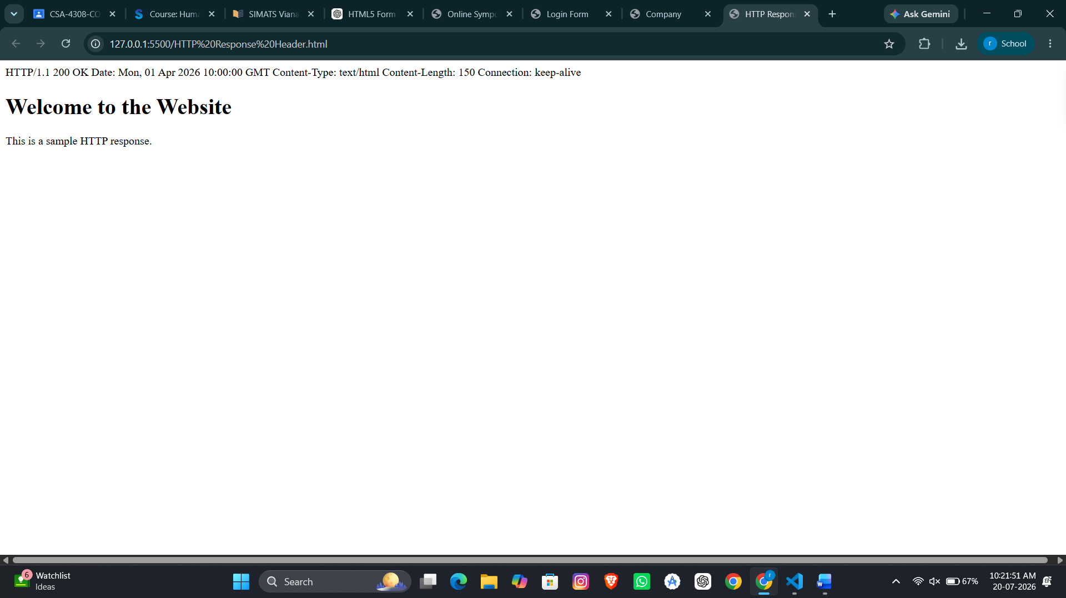

2: DOM Structure Analysis

Consider the following DOM tree representation:
<html>
<head>
<title>Test Page</title>
</head>
<body>
<div>
<p>Hello World
</div>
</body>
</html>
Questions:

- Identify missing or improperly closed elements.

The original HTML has the following errors:
- The <p> tag is not closed using </p>.
- The <!DOCTYPE html> declaration is missing.
- The <html> tag does not include the lang="en" attribute.
- Improper closing of elements can make the DOM invalid.

- Analyze how the browser will interpret this structure.

Modern web browsers automatically correct minor HTML errors.
- The browser will automatically insert the missing </p> tag.
- It will generate a valid DOM tree internally.
- Although the page may display correctly, different browsers may interpret the invalid
HTML differently.
- This can lead to inconsistent behavior across browsers.

- Determine the impact on rendering and layout.

• The text "Hello World" will usually be displayed correctly.
• Browsers will attempt to fix the missing closing tag automatically.
• Invalid HTML may cause unexpected layout or styling issues in some browsers.
• JavaScript that accesses the DOM may not behave as expected if the HTML structure is incorrect.

- Suggest corrections to make the DOM valid.

To make the DOM valid:
- Add the <!DOCTYPE html> declaration.
- Add lang="en" to the <html> element.
- Properly close the <p> tag using </p>.
- Ensure all HTML elements are correctly opened and closed.
- Follow proper HTML5 nesting and W3C standards.
These corrections produce a valid DOM structure that renders consistently across modern browsers

OUTPUT:
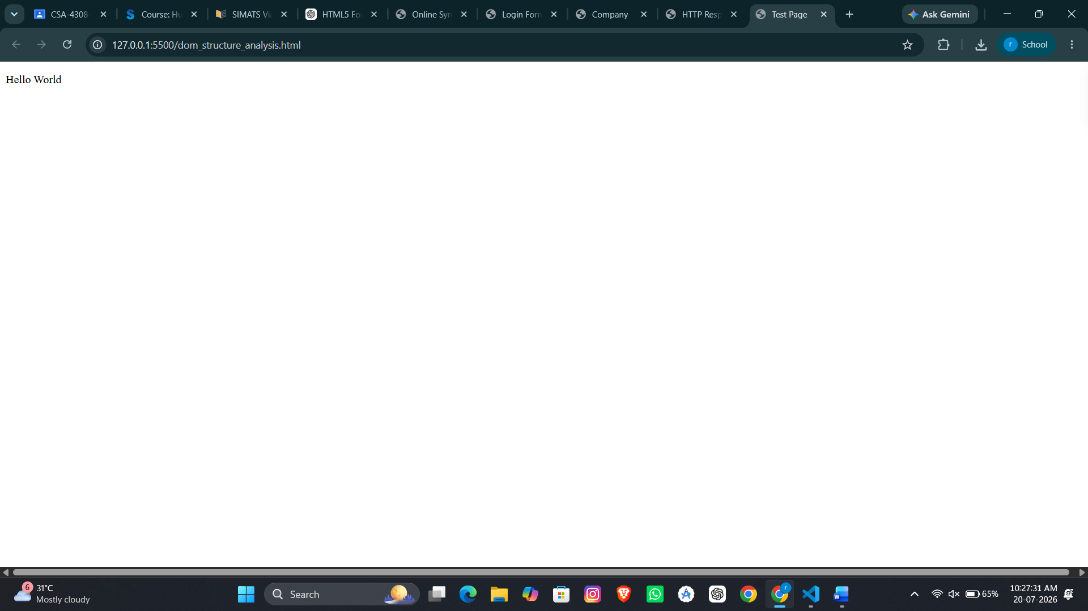

3: GET vs POST in Login System

A login system uses two different methods:
Method | URL Example | Data Visibility | Security Level
GET | /login?user=admin&pass=1234 | Visible in URL | Low
POST | /login | Hidden in body | Moderate
Questions:

- Interpret the differences in data transmission between GET and POST.

GET Method
  - Sends data through the URL as query parameters.
  - Example:
    - /login?user=admin&pass=1234
  - Data is visible in the browser address bar.
  - Suitable for retrieving data.

POST Method
- Sends data in the HTTP request body.
- Data is not displayed in the URL.
- Suitable for submitting sensitive information such as login credentials.

- Analyze which method is more suitable for login and why.

The POST method is more suitable for login forms because:
- It sends the username and password in the request body instead of the URL.
- Sensitive information is not exposed in the browser's address bar.
- It is the standard method used for authentication forms.
- It provides better security than GET, especially when combined with HTTPS.

- Identify security risks in using GET for authentication.

Using GET for login has several security risks:
- Username and password are visible in the URL.
- Credentials may be stored in browser history.
- URLs may be saved as bookmarks.
- Server logs may record the complete URL, including credentials.
- Credentials can be exposed if the URL is shared.
Therefore, GET should not be used for authentication.

- Suggest best practices for secure login implementation.
- Use the POST method for login forms.
- Use HTTPS to encrypt data during transmission.
- Never send passwords in the URL.
- Validate user input on both the client and server.
- Store passwords securely using hashing algorithms such as bcrypt or Argon2.
- Protect against CSRF (Cross-Site Request Forgery) attacks.
- Use secure session cookies with the HttpOnly, Secure, and SameSite attributes.
These practices help ensure that user credentials are transmitted and stored securely.

OUTPUT:
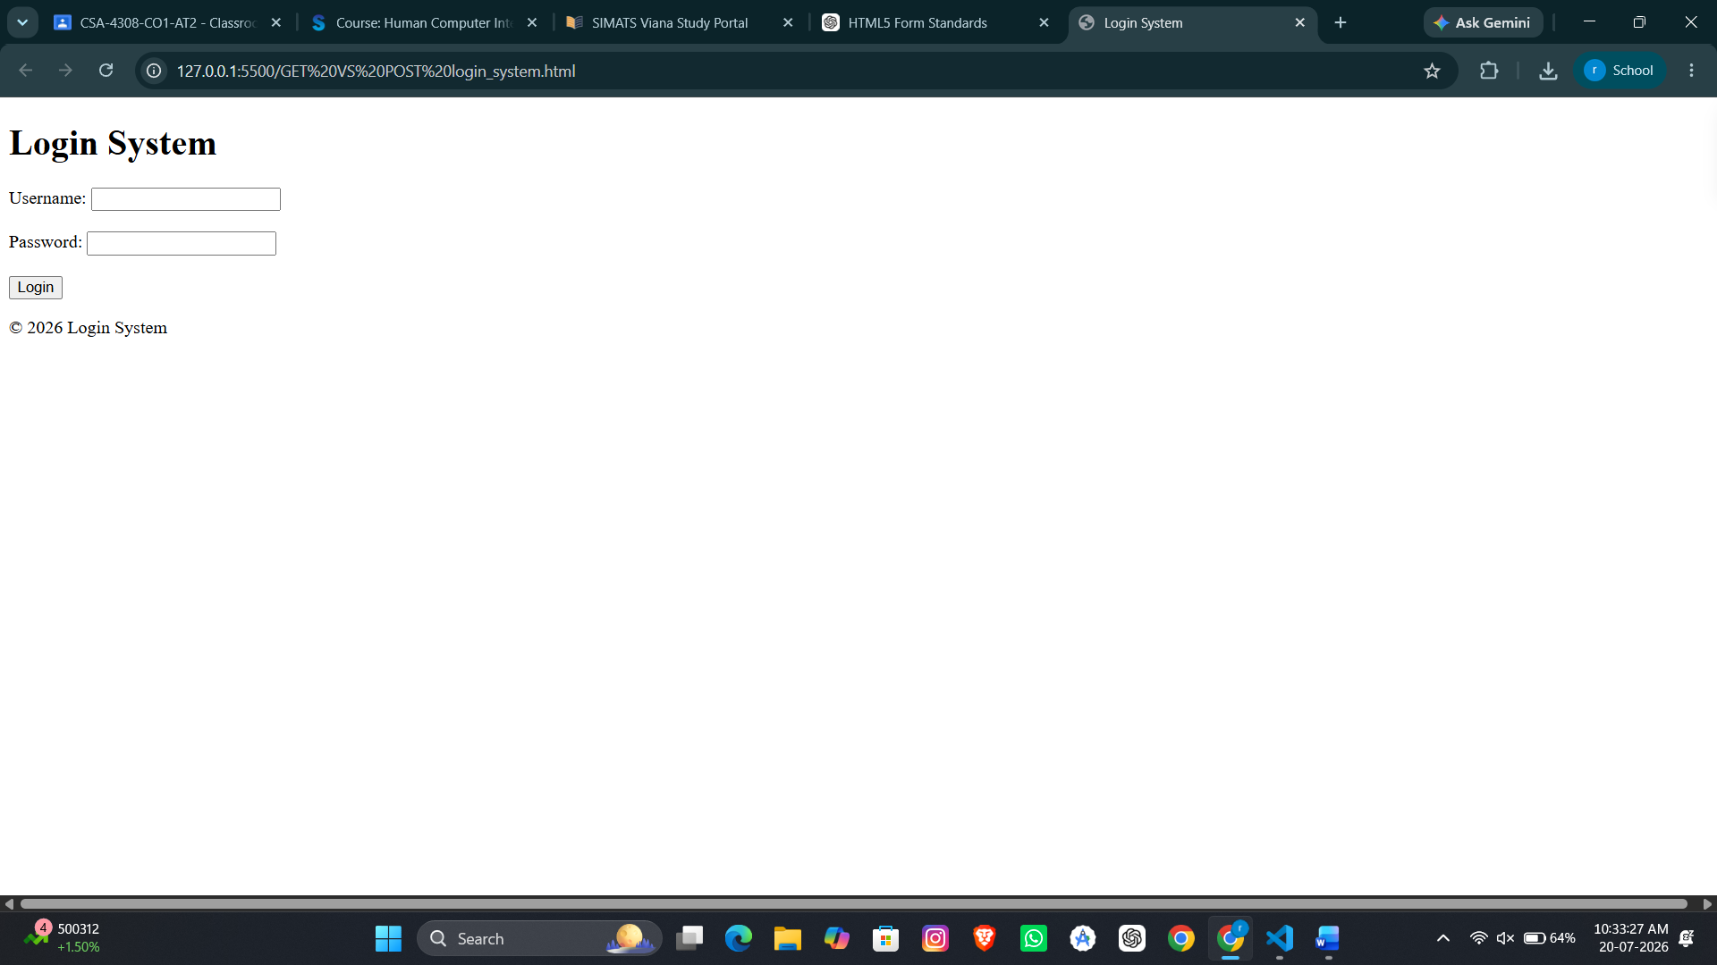

4: HTML Code Inspection

Analyze the following HTML snippet:
<!DOCTYPE html>
<html>
<head>
<title>Sample</title>
</head>
<body>
<h1>Welcome
<p>This is a paragraph
<img src="image.jpg">
</body>
</html>
Questions:

- Identify missing closing tags.
The original HTML has the following missing closing tags:
- <h1> is missing the closing tag </h1>.
- <p> is missing the closing tag </p>.
These tags should always be properly closed to maintain a valid HTML structure.

- Analyze issues with the <img> tag.

The original image tag is:
<img src="image.jpg">
Issues:
- The alt attribute is missing.
- The alt attribute provides alternative text if the image cannot be displayed.
- It also improves accessibility for users who use screen readers.

Correct Image Tag
<img src="image.jpg" alt="Sample Image">

- Determine how browsers will handle these errors.

Modern browsers automatically try to correct minor HTML errors.
- The browser will automatically close the <h1> tag when it encounters the <p> tag.
- The browser will automatically close the <p> tag before the end of the document.
- The page may still display correctly, but the HTML is not valid.
- Different browsers may interpret invalid HTML differently, which can lead to inconsistent layouts or behavior.

- Suggest a corrected version of the code.
The corrected HTML should include:
  - Proper closing tags for <h1> and <p>.
  - An alt attribute for the <img> element.
  - <!DOCTYPE html> declaration.
  - lang="en" attribute in the <html> tag.
  - <meta charset="UTF-8"> and <meta name="viewport"> for proper HTML5 compatibility.
These corrections ensure the HTML follows W3C standards, improves accessibility, and renders consistently across modern browsers.

OUTPUT:
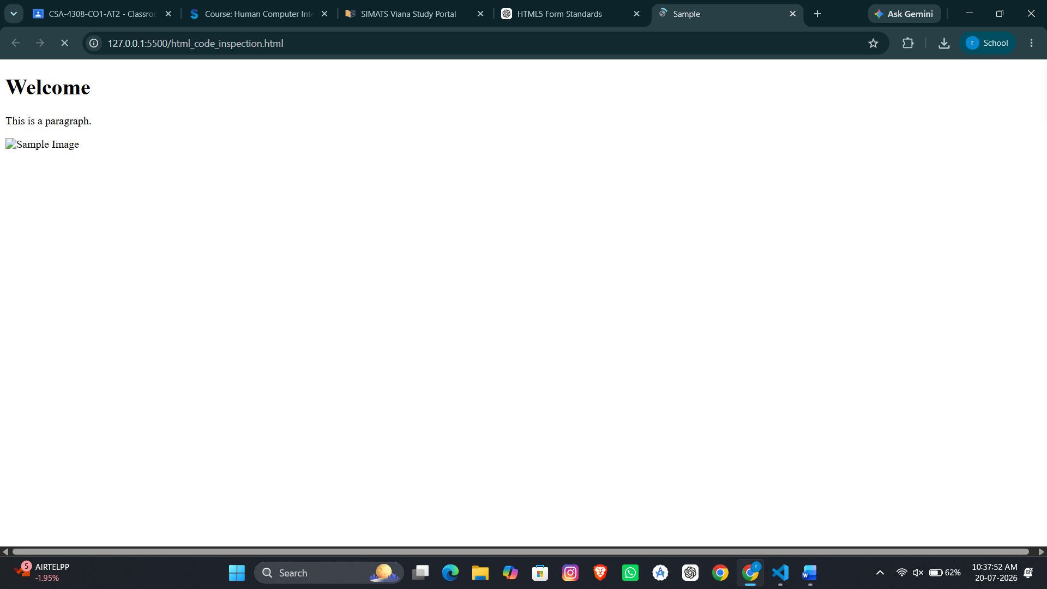

5: Browser-Server Communication Flow

The following sequence describes a web request:

- User enters a URL in the browser
- DNS lookup occurs
- HTTP request is sent
- Server processes request
- Response is returned
- Browser renders page

Questions:

- Interpret each step in the communication flow.
  - User enters a URL in the browser: The user types a website address (for example, www.example.com) into the browser.
  - DNS lookup occurs: The Domain Name System (DNS) converts the domain name into the corresponding IP address of the web server.
  - HTTP request is sent: The browser sends an HTTP request to the web server using the obtained IP address.
  - Server processes the request: The server receives the request, processes it, retrieves the required data, and prepares a response.
  - Response is returned: The server sends an HTTP response containing HTML, CSS, JavaScript, images, or other resources.
  - Browser renders the page: The browser interprets the received resources and displays the webpage to the user.

- Identify where delays can occur.

Delays may occur at the following stages:
  - DNS lookup may take time if the domain is not cached.
  - Slow internet connection can delay request and response transmission.
  - Server processing may be slow due to heavy traffic or complex operations.
  - Large files such as images, videos, or scripts can increase loading time.
  - Browser rendering may take longer if the webpage contains complex HTML, CSS, or JavaScript.

- Analyze the role of DNS in the process.

The Domain Name System (DNS) acts like the Internet's phonebook.
  - It converts a human-readable domain name (such as www.example.com) into the server's IP address.
  - Without DNS, browsers would require users to remember numerical IP addresses.
  - DNS enables the browser to locate and communicate with the correct web server.

- Suggest optimizations to improve performance.

- Use DNS caching to reduce lookup time.
- Use a Content Delivery Network (CDN) to deliver resources from nearby servers.
- Compress HTML, CSS, JavaScript, and images to reduce file size.
- Minify CSS and JavaScript files.
- Enable browser caching for static resources.
- Optimize server performance and database queries.
- Use HTTP/2 or HTTP/3 for faster communication.
- Reduce unnecessary HTTP requests by combining files where appropriate.

OUTPUT:
